# **CREATING A OPERATING SYSTEM FROM DEBAIN DISTRIBUTION**

step 1: installation of virtual box

Go to <https://www.virtualbox.org/wiki/Downloads>

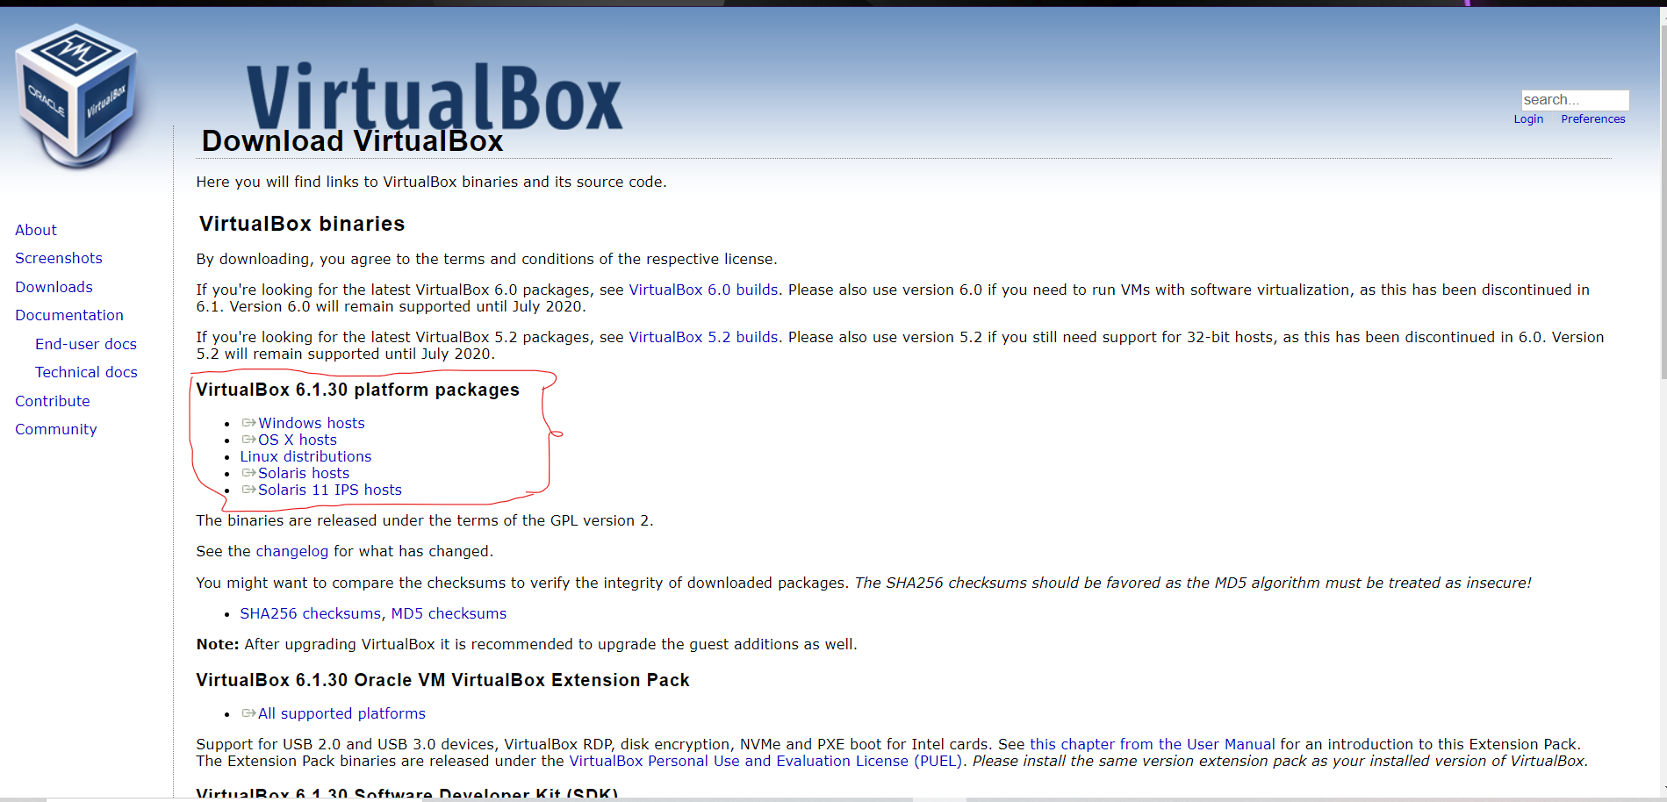

choose the executable which is compitable with your host operating system and download the executable after that run the executable a window is opened as shown below.

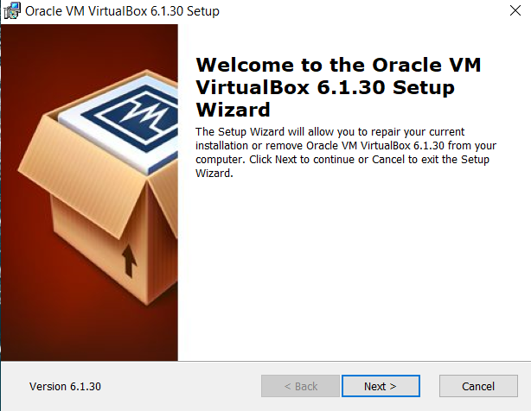

simply click next 3 times and then click install after installation completed click finish .A shortcut is created on your desktop

resources:

<https://www.virtualbox.org/manual/ch02.html> this is the official installation manual

step 2: installation of template distro

choosing a template distro:

first step is we have to choose a linux distro to use it as a template. there are lot linux distributions like debian, archlinux ,fedora, linux mint …..etc .In this project we are choosing debian as our template

installation:

go to <https://www.debian.org/distrib/> and download small installation image depending on your system architecture(64bit/32bit)

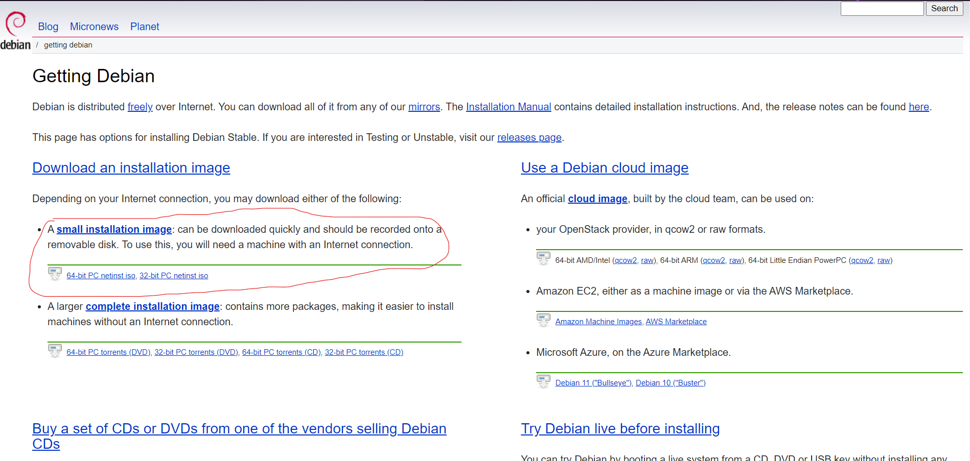

step 3: importing the image into virtual box

open the virual box and click on the new

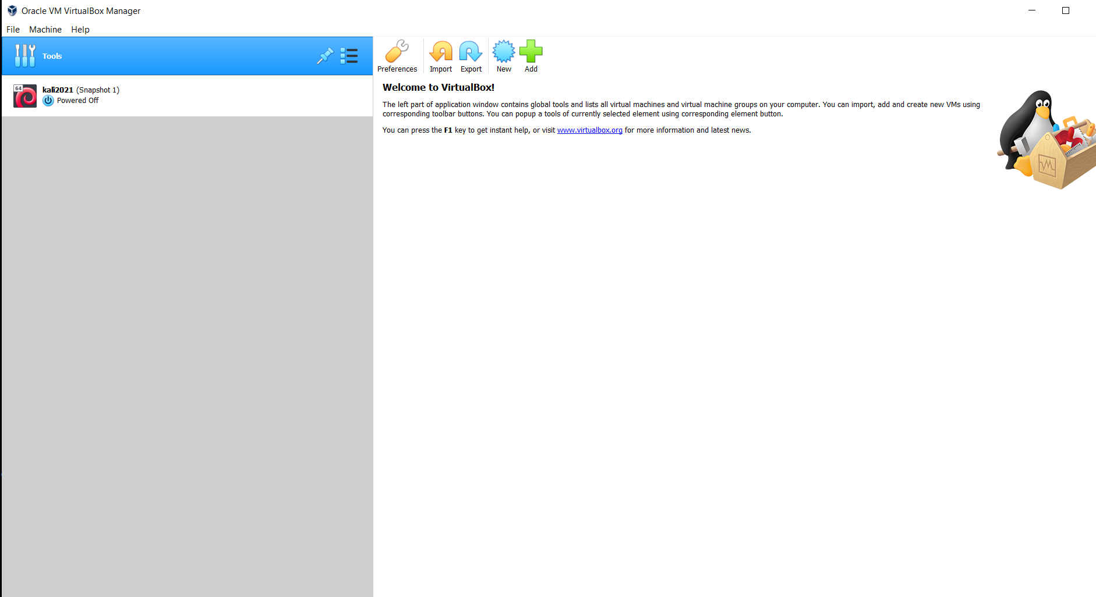

a window appears as shown below

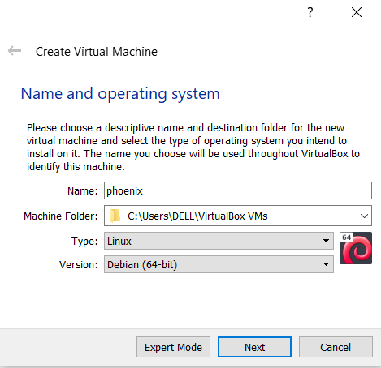

give a name to the operating system and set type to linux and version to debian 64/debian 32 depending on image u downloaded

and click next

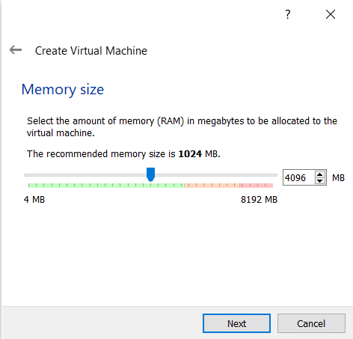

allot the memory and click on next

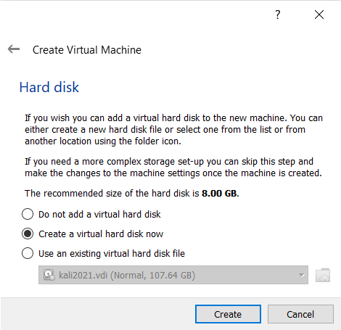

select create a virtual hard disk now option and click on create

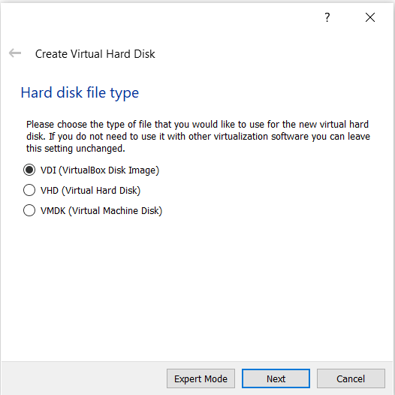

select VDI(virtual disk image) option and click on next

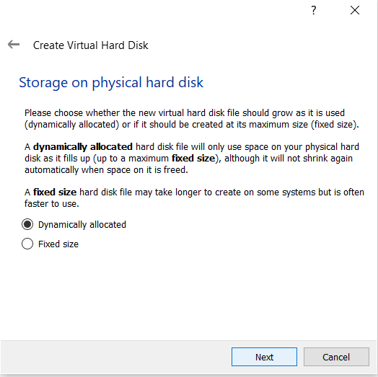

select dynamically allocated and click on next

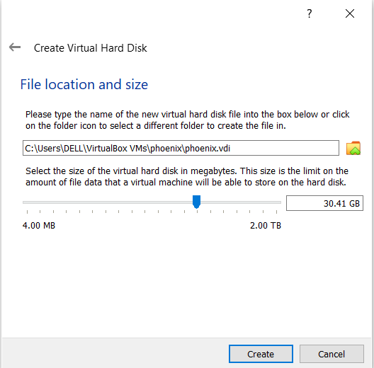

allocate size of virtual hard disk and click on create.our virtual machine is created

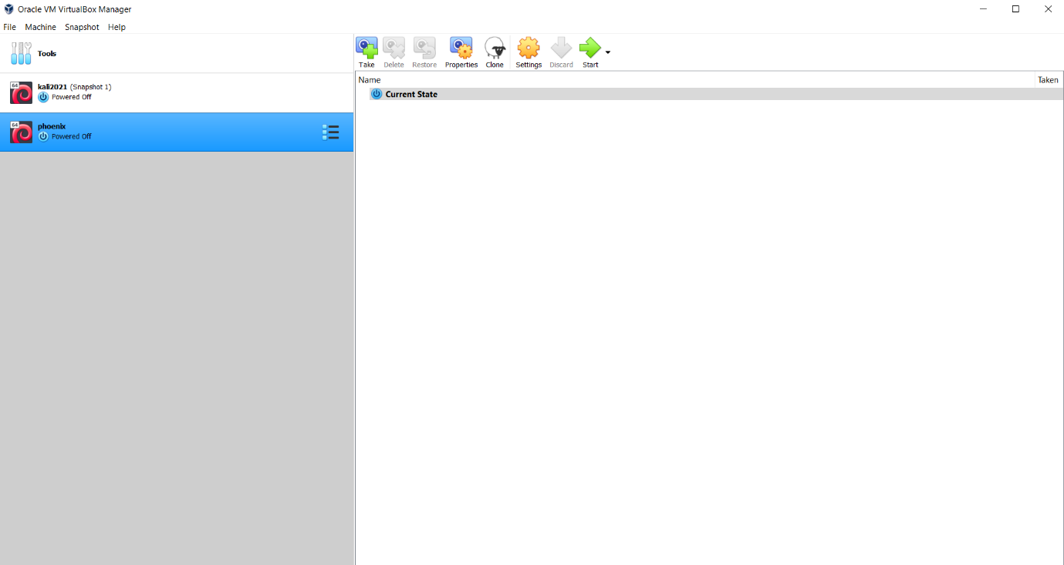

now select our virtual machine and click on start

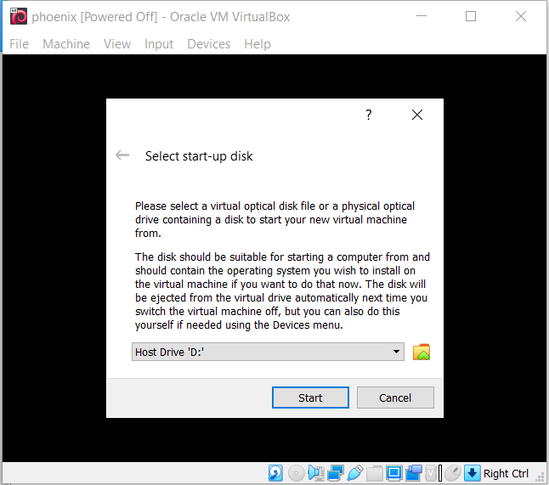

click on the folder icon

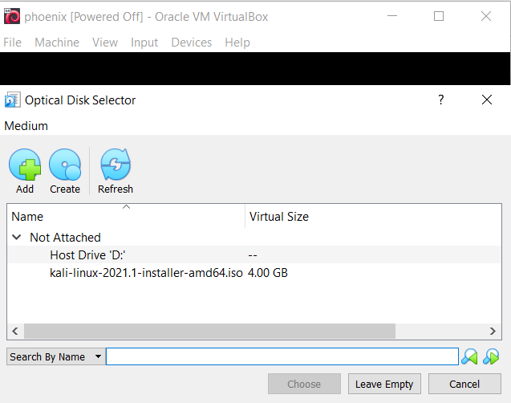

click on add and select the downloaded debain image and click on start

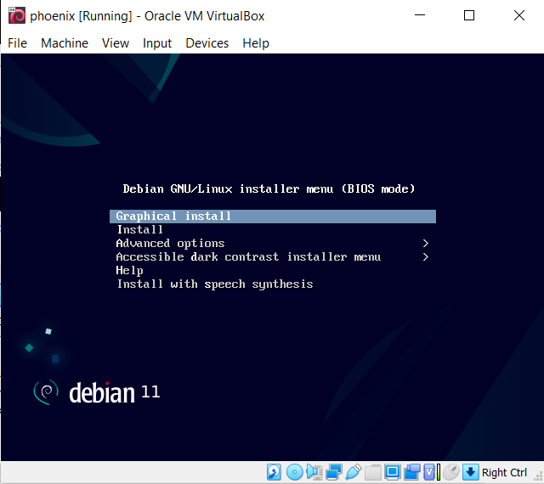

choose the graphical install and click enter

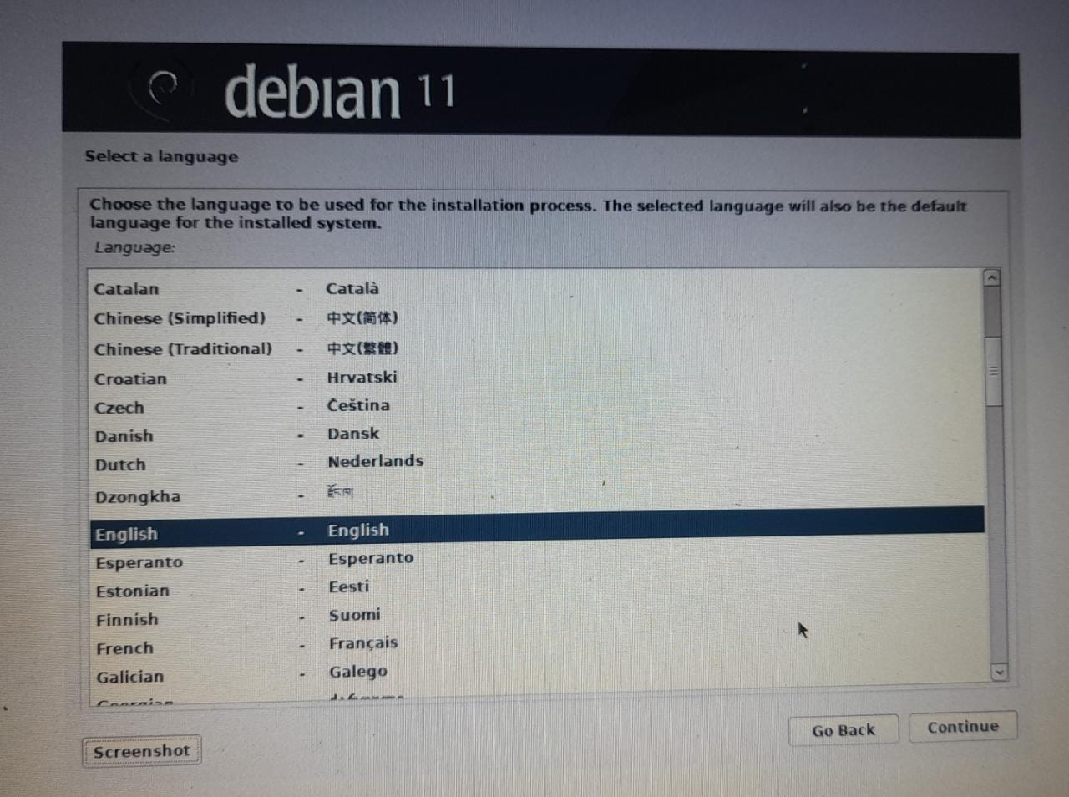

select the language and click on continue

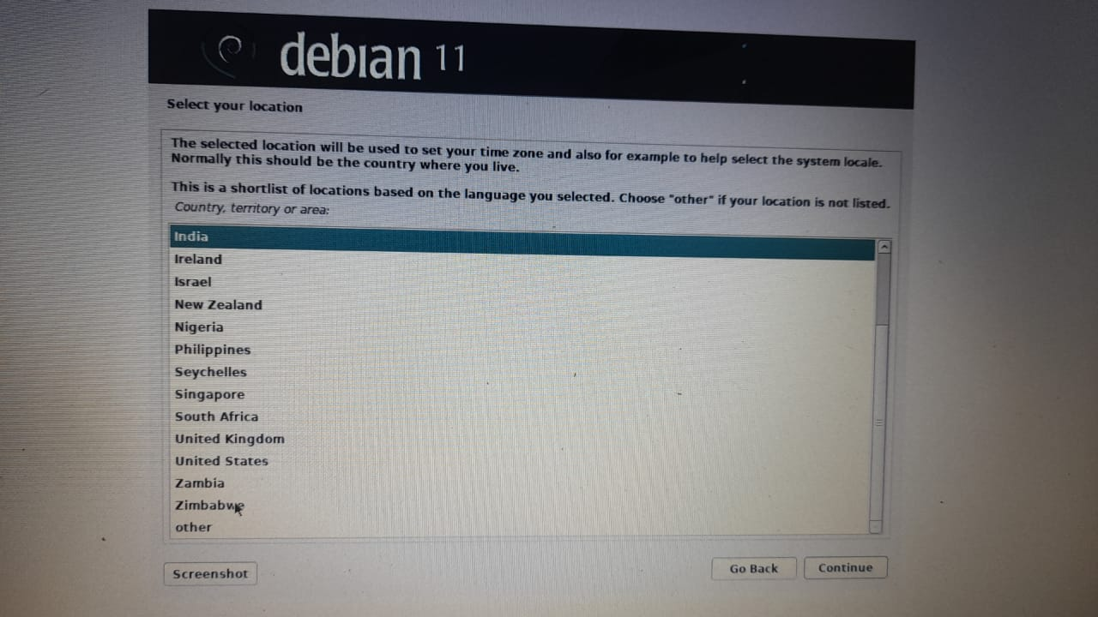

select the country and click on continue

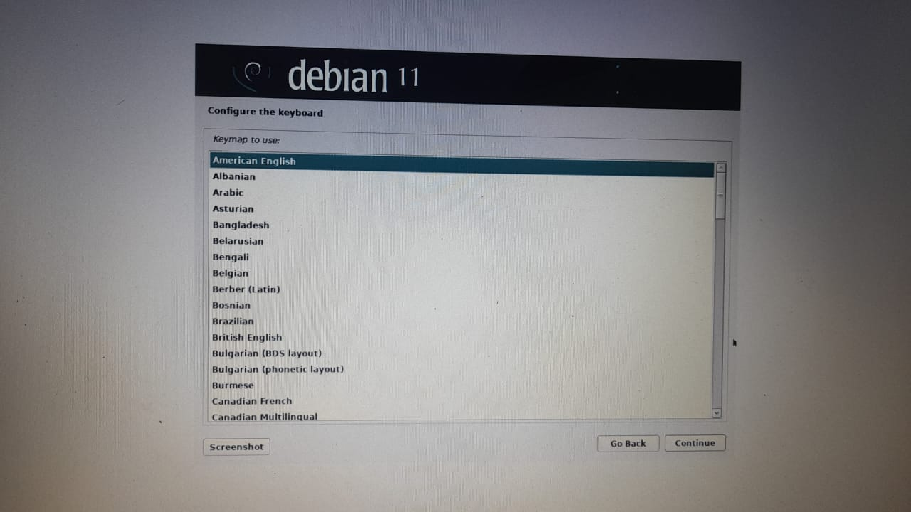

select a keyboard configuration and click on continue

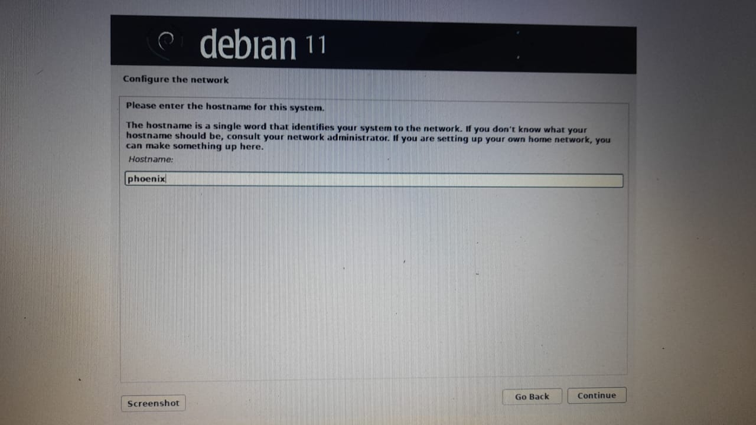

choose a host name and click on continue

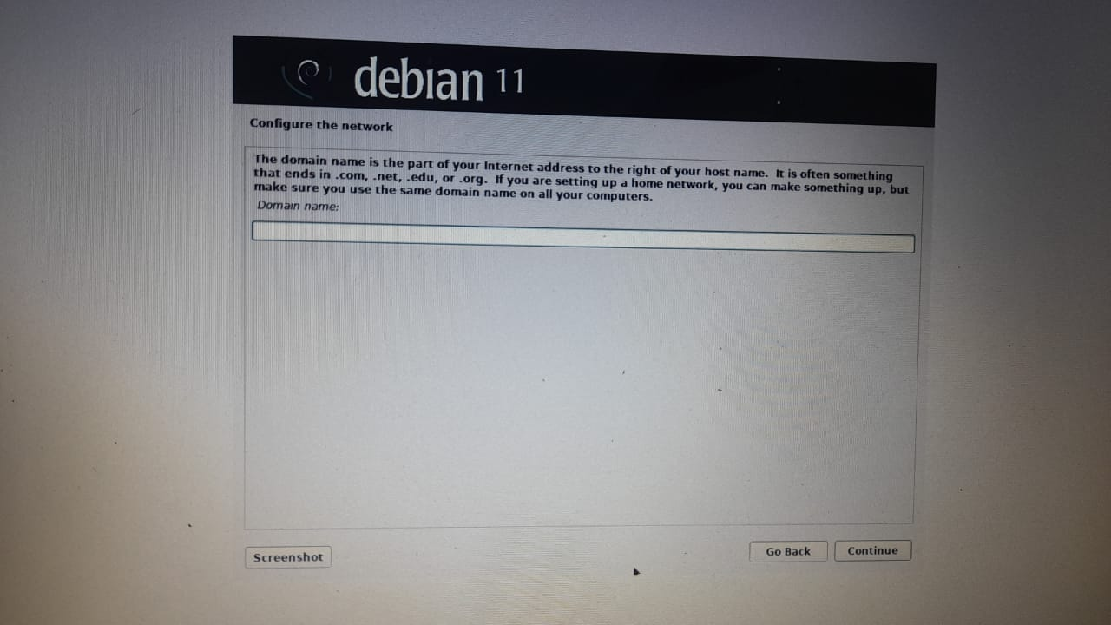

leave this to default and click on continue

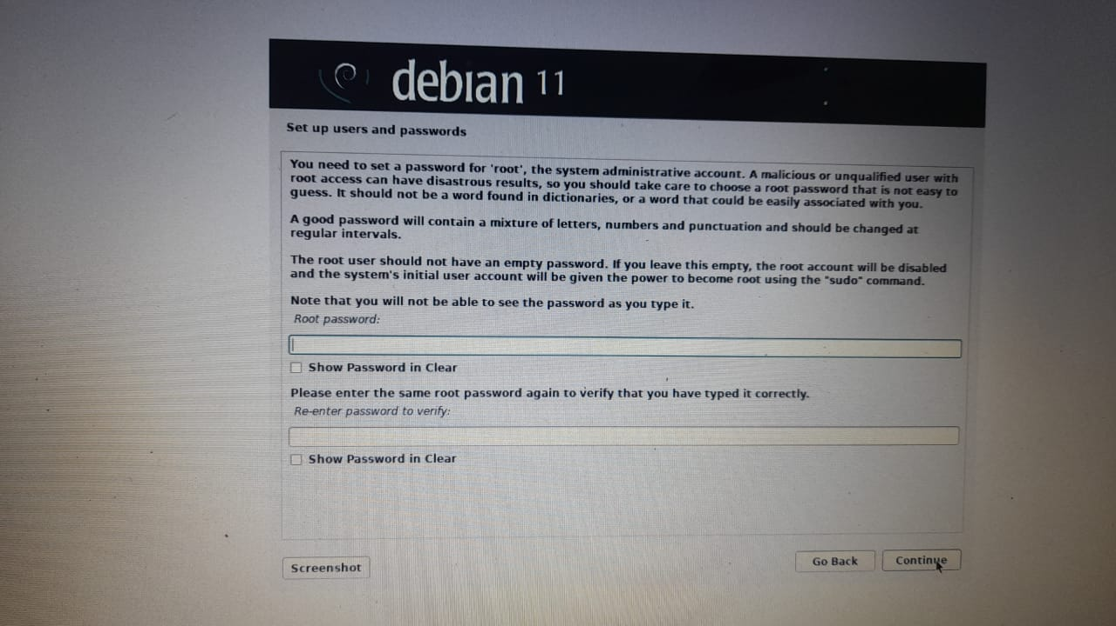

choose a password for root acess this password is used when gaining acesss to root/superuser

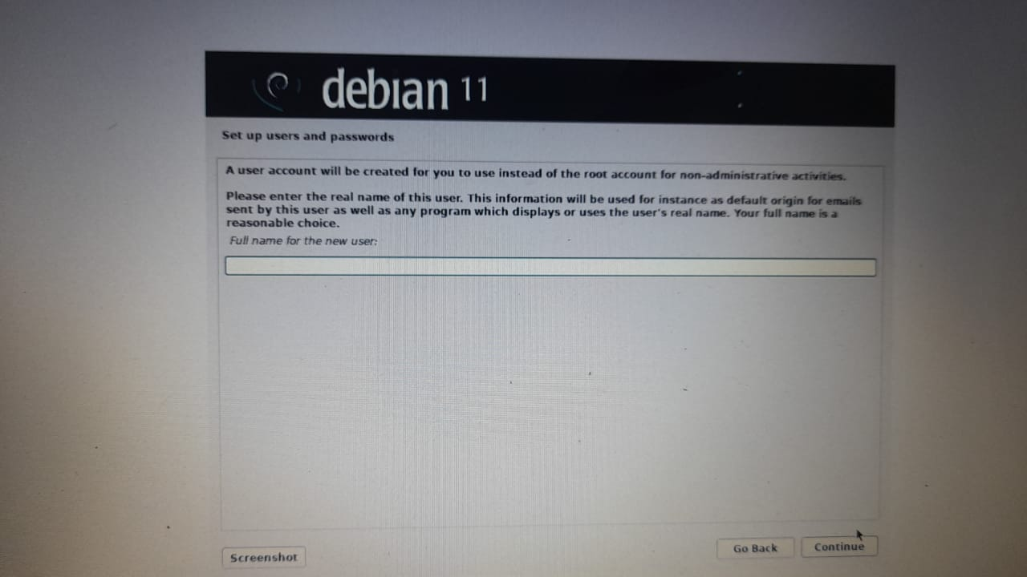

choose the full user name and click on continue

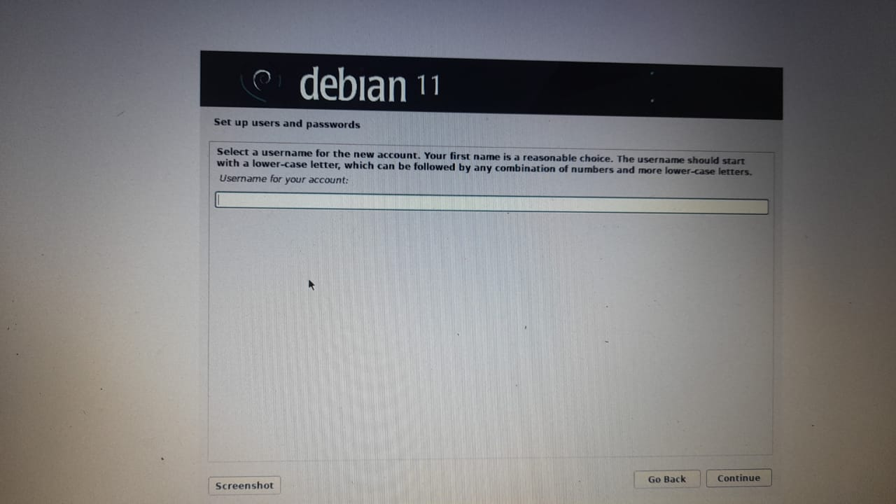

choose the username and click on continue this is the username we use when we are logging into system

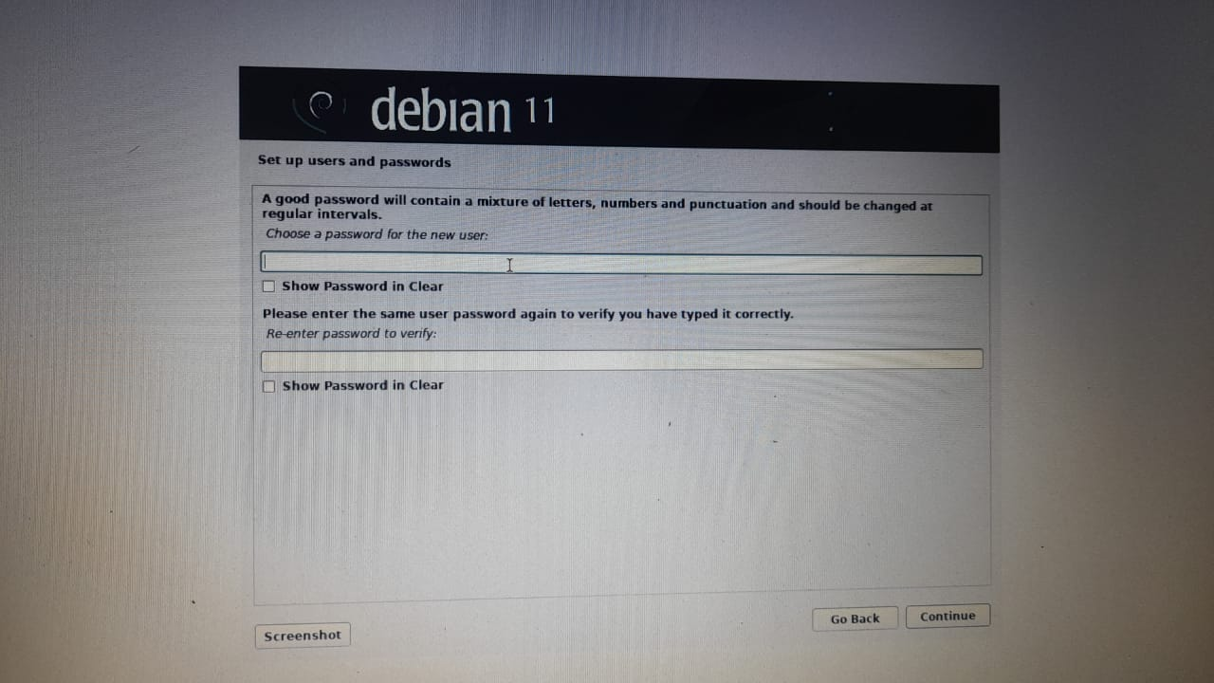

choose a password and click on continue this is the password we use when we are logging into the system

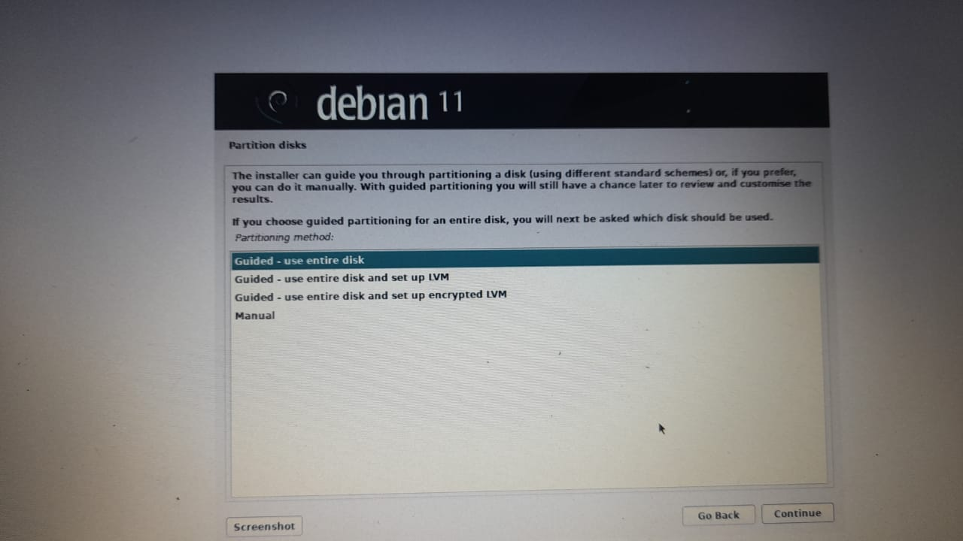

select the guided-use entire disk and click on continue

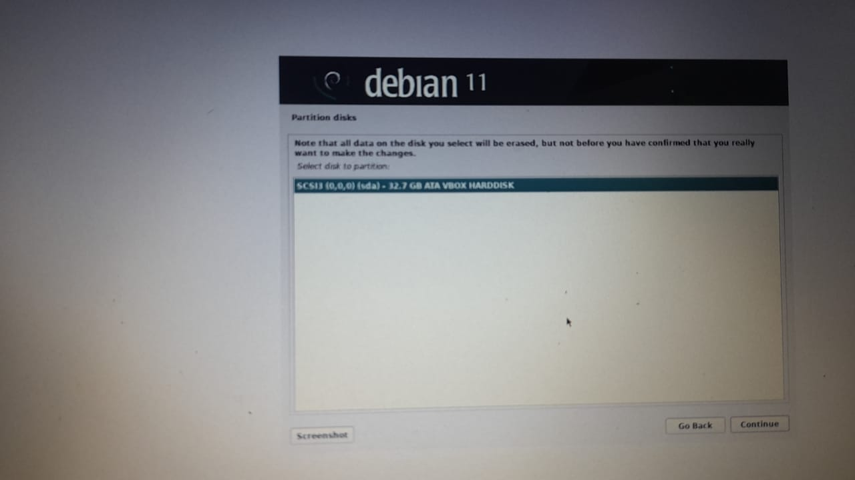

leave it to default and click on continue

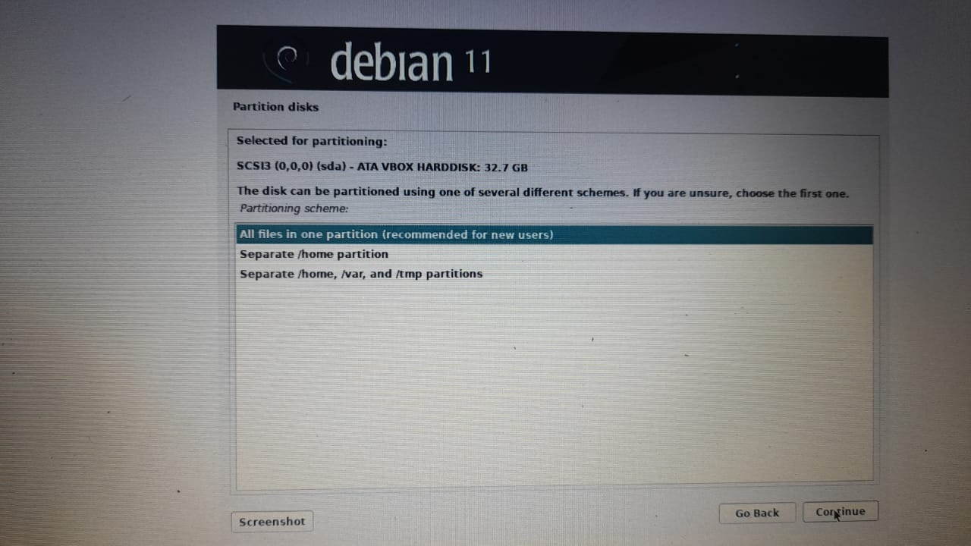

leave it to default and click on continue

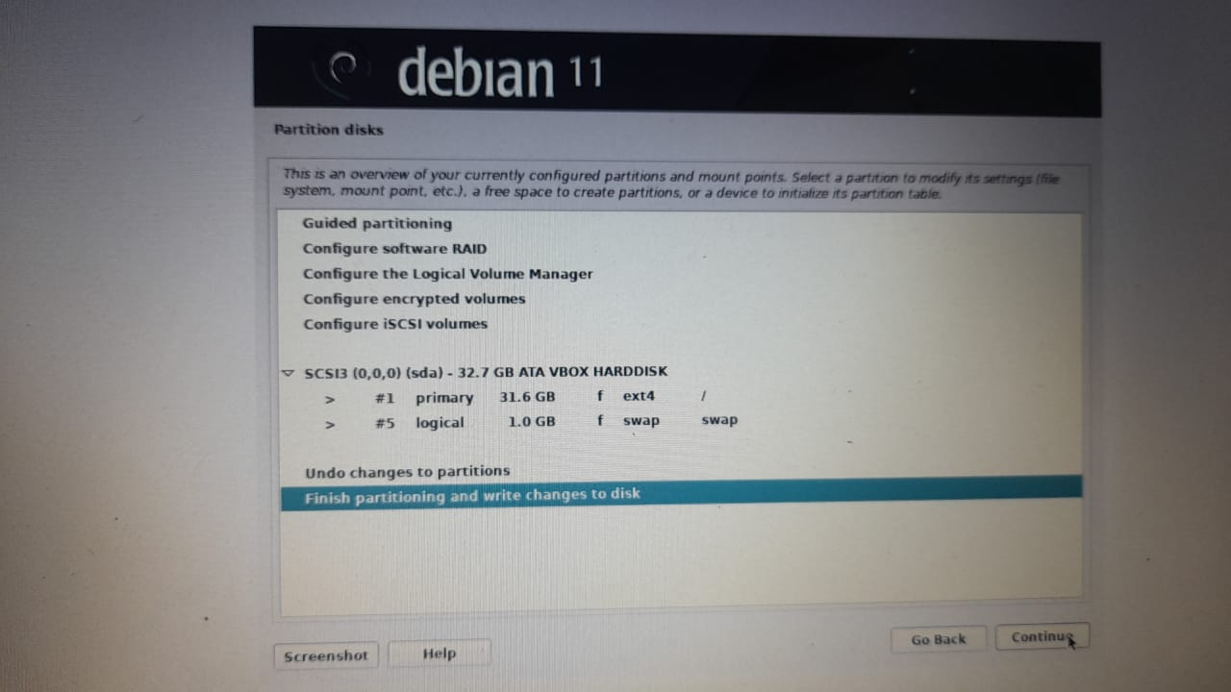

leave it to default and click on continue

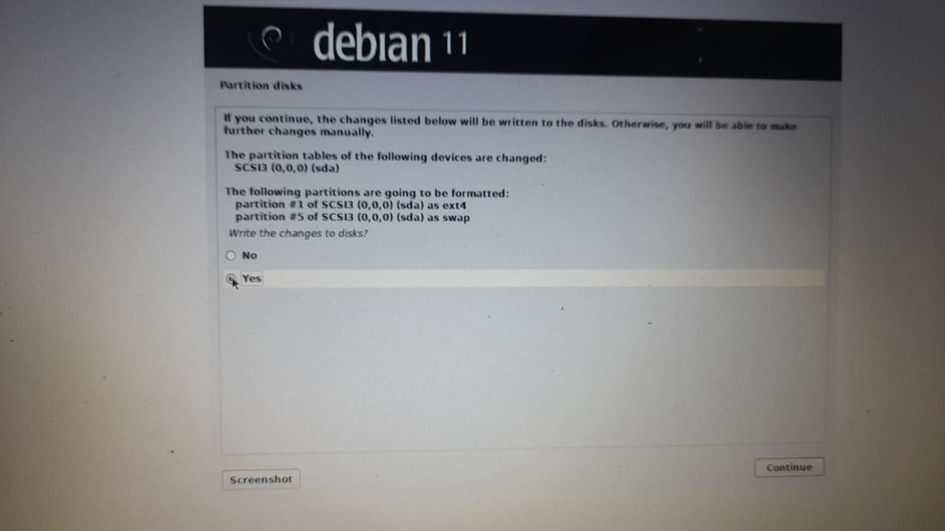

select yes and click on continue

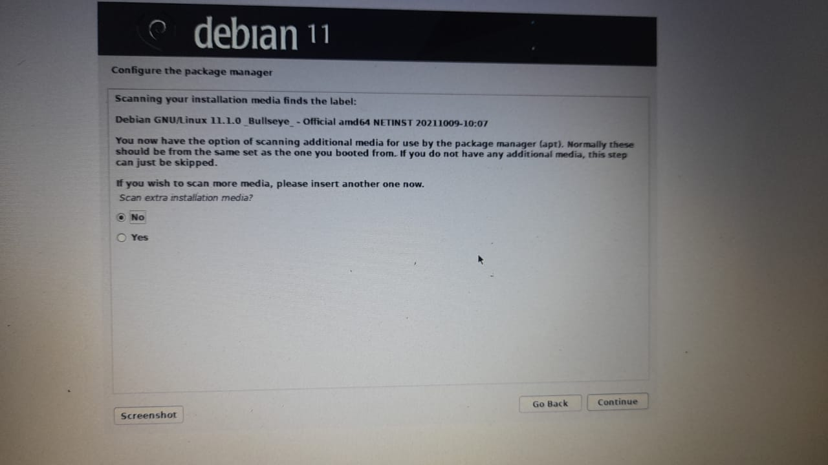

select no and click on continue

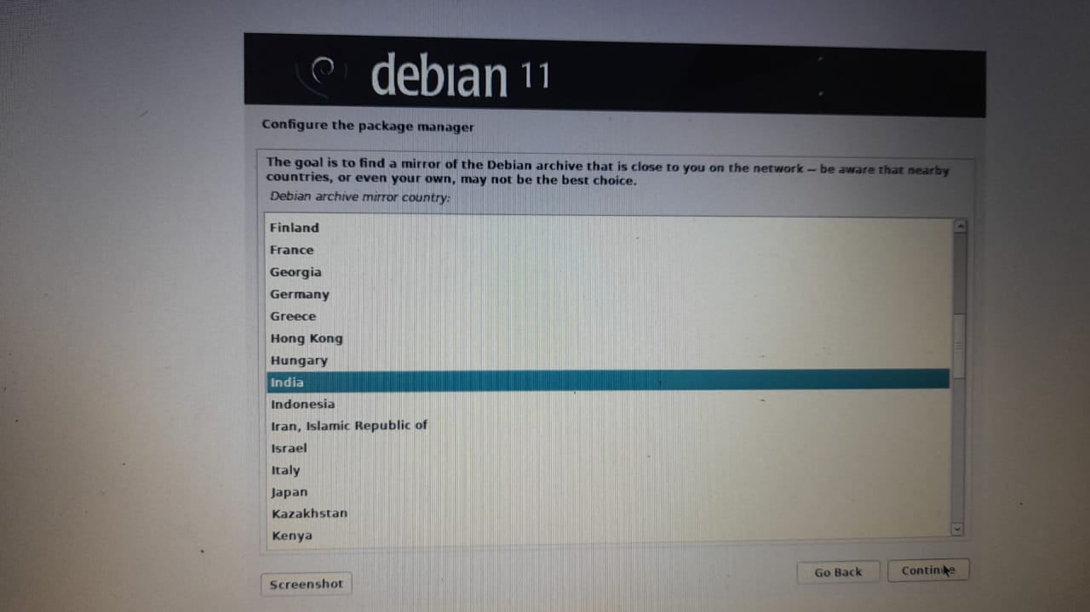

select your country and click on continue

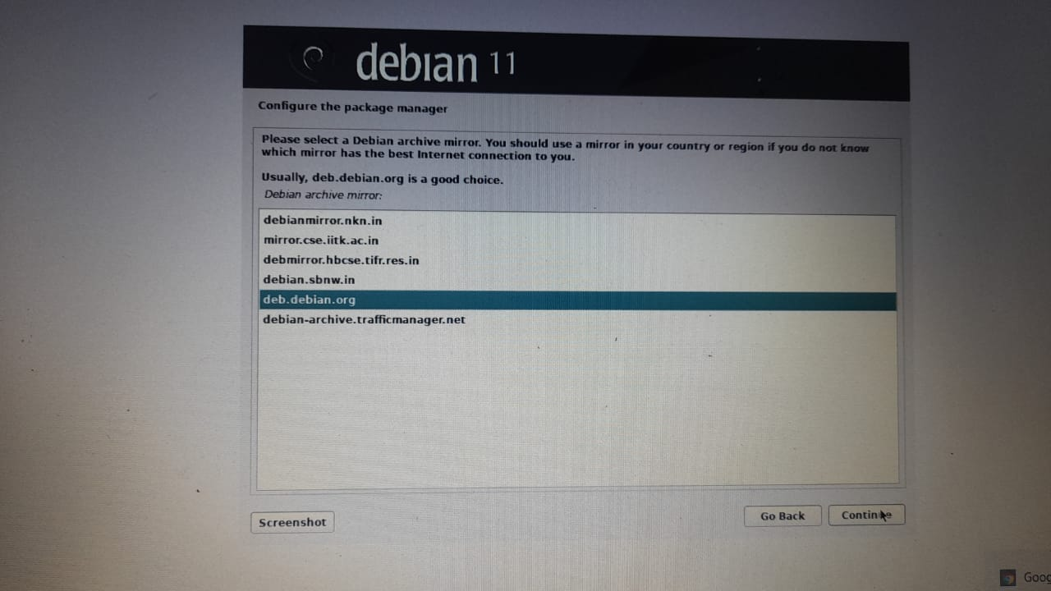

leave it to default and click on continue

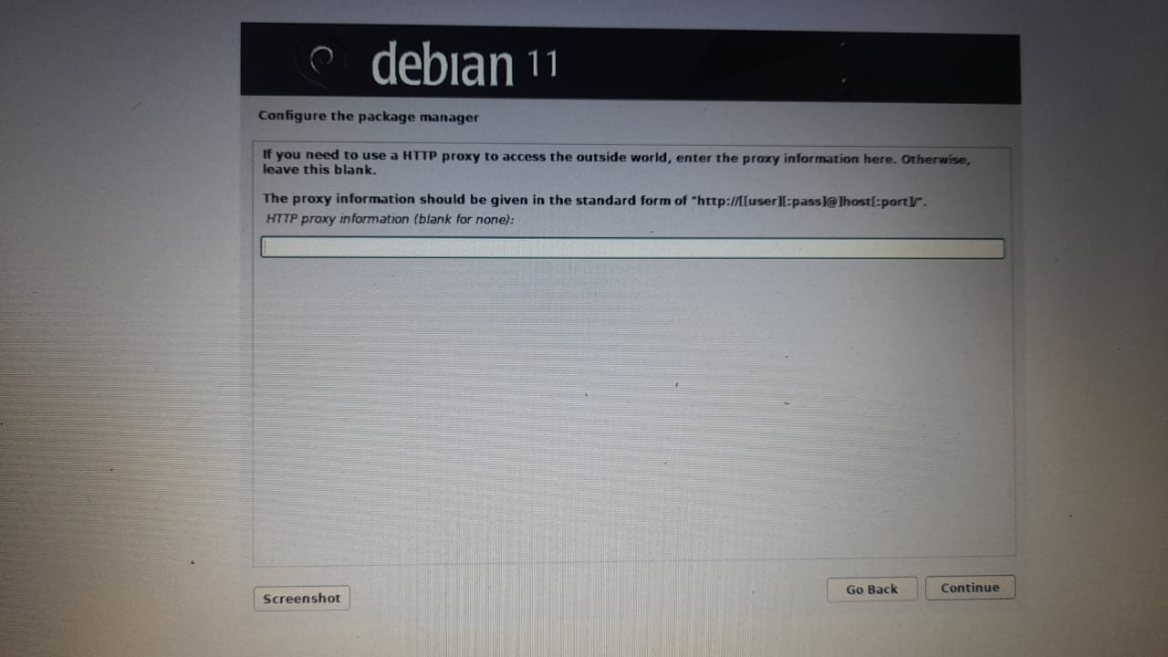

leave it to default and click on continue

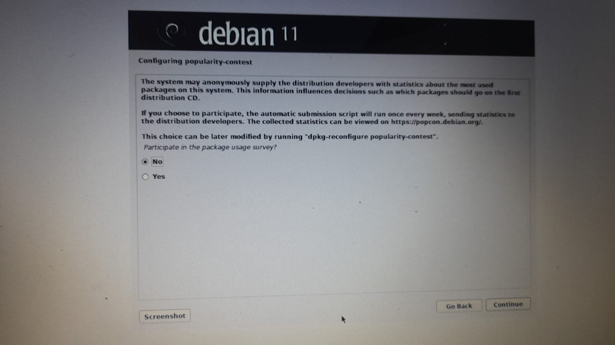

select no and click on continue

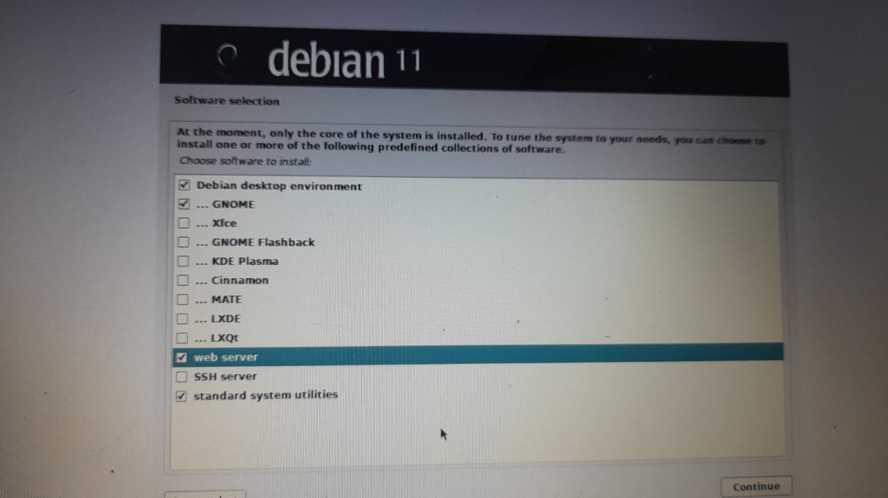

select the software you need to install and click on continue

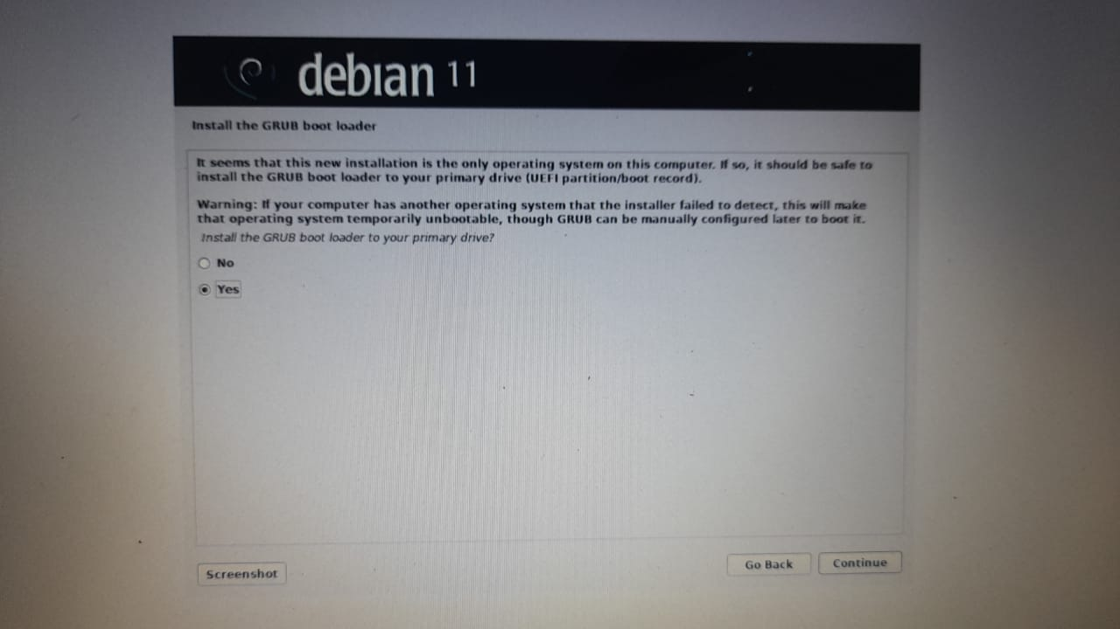

select yes and click on continue

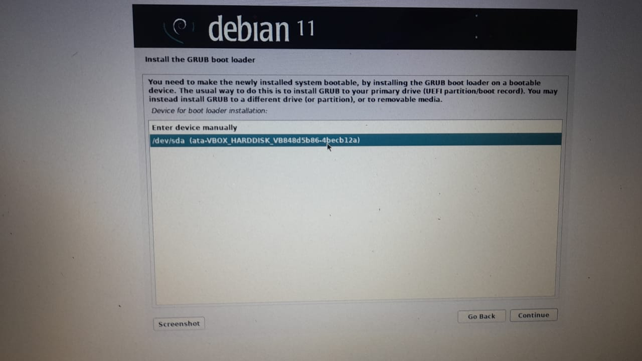

select the device and click on continue and installation starts after the installation is completed it automatically reboot and start our new virtual machine.after everything is done it looks like as shown

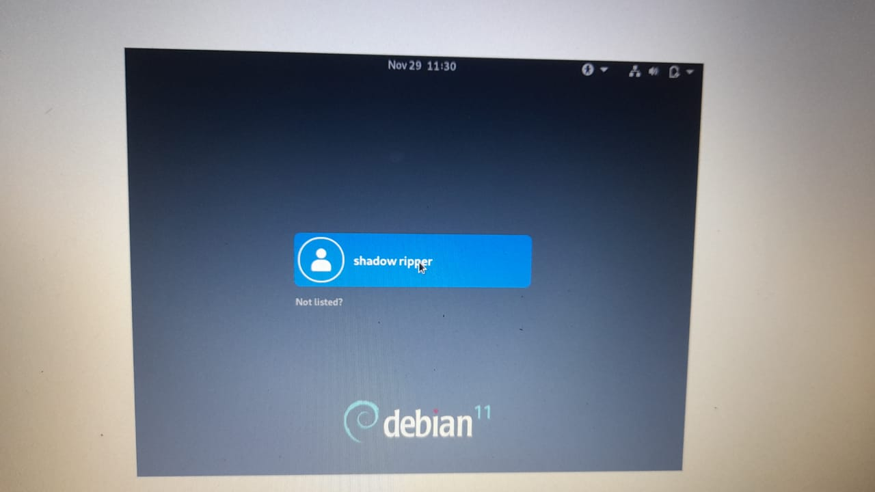

click on the user it will ask for the password type it then you will logged into your new operating system

NOTE: after logging in we need to change the resolution to do that rigth click the mouse and click on display settings in that click on resolution and change it (recommended is 1920*1200)

step 3: modifiying